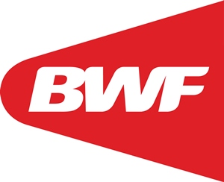
BWF ID NO:

NEW PLAYER’S PROFILE

NAME OF TOURNAMENT: World Senior Badminton Championships at Sweden.
COUNTRY REPRESENTED:
SURNAME in capital letters:
GIVEN NAME:
CALLED NAME:
EVENT: Singles ( ) Doubles (X) Mixed ( ) Please mark X in appropriate block
DATE OF BIRTH:
PLACE OF BIRTH:
GENDER :
CITY:
COUNTRY:
PRESENT RESIDENCE ADDRESS

HEIGHT:
WEIGHT:
BADMINTON ICON (NON BADMINTON)
FIRST PLAYED BADMINTON:
- YEAR :
- AGE
WHAT YEAR DID YOU JOIN THE NATIONAL SQUAD:
NOTE: Member Associations are advise to complete the player profile biodata for new BWF ID numbers.

